March 14th Assignment:

**Exercise 1: Get All the Jira tickets from the Project AP**

End Point URL: <https://restapijira.atlassian.net/rest/api/2/search?jql=project=AP>

Total Count of records: 104

Screenshot from UI:

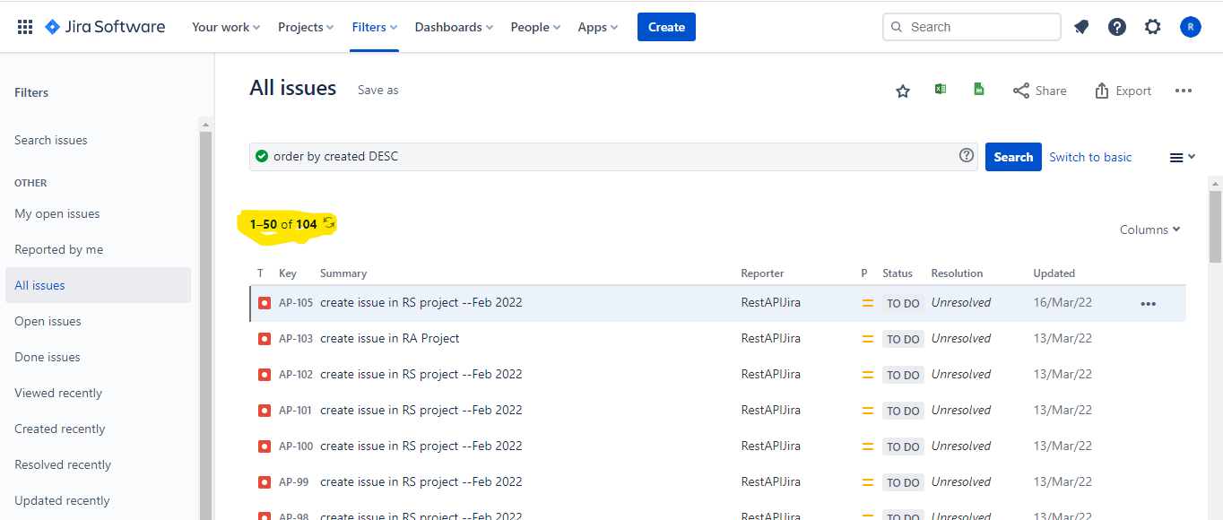

Screenshot from Postman:

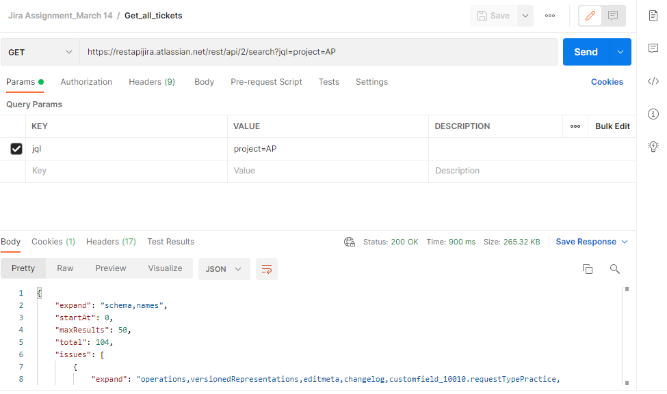

**Exercise 2: Get all the issues that has been created within 24 hours**

End Point URL: https://restapijira.atlassian.net/rest/api/2/search?jql=project=AP%26created >= -24h

Total Count of records: 1

Screenshot from UI:

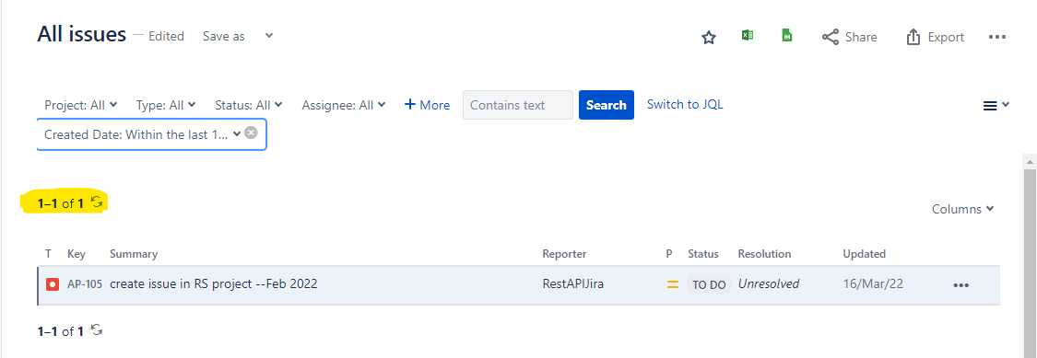

Screenshot from Postman:

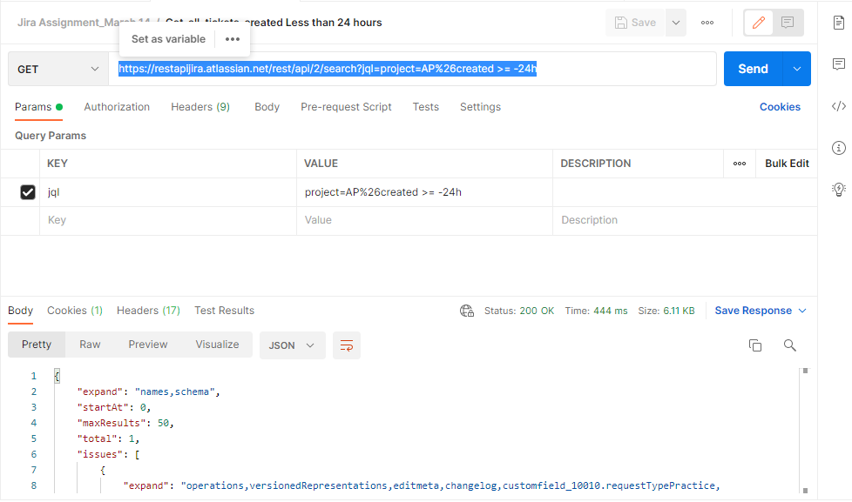

Postman Collection containing both Request:

